Log on details:
Computer log on: Reception
Password: @WPS3687
Email: reception@wpsychology.com
Password: @2Wps3687re
Alarm code - 8188
Contact details:
Work phone: 9746 8088
Fax: 9746 8188
Address: 2 Exford Road, Melton South (Crn of Creek Street)
PO BOX 2233 Melton South VIC 3338

WPS Opening hours:
Monday 9am – 5.30
Tuesday 9am – 7pm
Wednesday 9am- 7pm
Thursday 9am – 7pm
Friday 9am – 6.30pm

Office Staff:
Angelo Pagano – Director
Fiona Kenna – Practice Manager
Alyce Stead – Office Manager
Kylie Storey – Reception
Leah Wombwell – Bookkeeper / Accounts (including admin pay)

PSYCHOLOGISTS:
Angelo Pagano | Clinical Psychologist | Monday – Friday & Saturday in Essendon | $170.00 with a Medicare care plan / referral $124.50 rebate | Director of WPS
Diane Bulman | General Psychologist | Tues, Wed & Thurs. | $155.00 with a Medicare care plan / referral $84.80 rebate | Has TPS clinic times only. (do not book TPS client outside of this time)
Sarah Rostron | General Psychologist. | Tuesday, Wednesday & every second Friday | $155.00 with a Medicare care plan / referral $84.80 rebate | Child Psych & Adult Psych
Joseph Gagliano | General Psychologist. | Every Wednesday & every 4th Monday | $155.00 with a Medicare care plan / referral $84.80 rebate | Adult Psych.  Speciality: Workcover
Suzanne Magtanong – | General Psychologist. | Monday – Friday | $155.00 with a Medicare care plan / referral $84.80 rebate | CHILD PSYCH
Simon Lush | Clinical Psychologist. | Monday & Wednesday | $170.00 with a Medicare care plan / referral $124.50 rebate | Adult Psych.  Runs Meditation group
Peter Saunders | Clinical Psychologist. | Fridays | $170.00 with a Medicare care plan / referral $124.50 rebate | Adult Psych
Laura Smolcic | Clinical Psychologist. | Tuesday & Thurs in Caroline Springs  Friday Melton | $170.00 with a Medicare care plan / referral $124.50 rebate | Adult
Lauren Giarrusso | Clinical Psychologist. | Tuesday only | $170.00 with a Medicare care plan / referral $124.50 rebate | Adult
Jenny McColl | General Psychologist | Tuesday & Thursday | $155.00 with a Medicare care plan / referral $84.80 rebate | Couples therapy
Rozalia Hecht | General Psychologist | Fridays only | $155.00 with a Medicare care plan / referral $84.80 rebate | CHILD
Danielle De Guara | General Psychologist | Monday / Wednesday | $155.00 with a Medicare care plan / referral $84.80 rebate | 12yrs +

NAMING ALL CORRESPONDANCE

Please use the following format
Capital letter for the first and last initial
First 3 letters of the Surname, followed by first 3 letters of the first name and then an item description and date.
i.e) Alyce Stead has a GP referral from 5/7/18

- SteAly GP ref 050718

- SmiBob report request 050718

- SteAly corro from psychiatrist 050718

- SteAly Intake form 050718

Please use this format for ALL documents to be name

SMS REMINDERS
Bulk SMS reminders – Existing Clients
- In diary, go to the day you wish to send the reminder for
- Left hand side in Frontdesk, select reports and utilities
- Select SMS/Email reminders
- Click “By Practice” and select Psychologist
- Click SMS
- Deselect ALL clients by unticking the box.
- Utilise template number 1 – SMS REMINDER CONFIRM OK
- Replace “next appointment” field with the actual date and time of client appointment
- Send SMS.
- Triage on Frontdesk card will disappear
- Adjust date / time, template if required.

Bulk SMS reminders – New Clients
- In diary, go to the day you wish to send the reminder for
- Left hand side in Frontdesk, select reports and utilities
- Select SMS/Email reminders
- Click “By Practice” and select Psychologist
- Click SMS
- Deselect ALL clients by unticking the box.
- Utilise template number 2 – 1st APPT – Remember: ADJUST address as per where the Psychologist is located i.e.) Melton South, Moonee Ponds, Essendon.
- Replace “next appointment” field with the actual date and time of client appointment
- Send SMS.
- Triage on Frontdesk card will disappear
- Adjust date / time, template if required.

Phone Messages:
Often people call to speak to a Psychologist, this may be:
- Clients – or family members
- GPs
- Other health care professionals
- Workcover
- Third party case managers
- Corrections
Please do not give out any information about clients – including any information about the client’s attendance and appointments as this is a breach of privacy and confidentiality.
Advise the caller that they can send an email through to reception@wpsychology.com and we can pass this on to the Psychologist. Forward this email to the Psychologist and also attach to Front Desk.
Alternatively advise them you will pass on a message to the Psychologist:
Write an email detailing:
- Which client it is regarding
- What the enquiry is (if mentioned by the caller)
- Caller’s name and organisation if applicable
- Contact details
- Available times to reach them (this avoids phone tagging!)
Before sending to the Psychologist, copy the text of the email.
Open up the client card on Front Desk and make an ‘Event’.
The event should be marked as ‘Follow up’.
Paste email text into event and save.
This allows us to track the phone messages and confirm we have notified the Psychologists as they often call multiple times.

TAKING OFF MESSAGES FROM NIGHTSWITCH (VOICEMAIL)
- Select message button on the reception phone
- Arrow down to “Main”
- Select Main
- Listen to message and delete
- Please ensure to return call phone messages, even a missed call phone number and create an event in Frontdesk.

TRIAGE OF NEW CLIENTS

- Create client card on FD for all new clients
- Request copy of referral (email or hard copy)
- Attach referral to FD and create a new client recall “awaiting triage as a note”. Please also replicate this note in events on Frontdesk.
- Email Angelo and / or Fiona with the client code “SmiBob” NC triage request.
- Please shred the original – When necessary & all the steps have been followed to ensure we don’t “loose” a file.

As most Psychologists are at capacity, we will start a new client waiting list. (This will apply to both adult and children)

When actioning a GP review:
- Scan
- Attach
- Make an event with the date being the GP review date & change the event type to “GP REFERRAL”. This note will go pink. In the event, please ensure you are putting the accurate number of sessions remaining, i.e.) 4 or 6.
- Update billing details for the GP including the date of the referral.
- Copy the GP name in notes
- If Psychologist does not require a hard copy, please shred
- Move the completed scan into the appropriate “month” folder.

Djerrwarrah Health Services EAP Invoicing process (billed monthly)
(May not need to be billed monthly, bill when 3+ clients are on invoice)
- 6 session per client
- Needs “cost centre code/ department code” prior to appt. If client isn’t aware of this they can call HR on 5367 9801, advise them of the department and obtain code.
- Go to Djerrwarrah Health Services
- Manager Human Resources – Email invoices to andreac@djhs.org.au
- Transactions
- Invoices
- Unvoiced items – Preview
- Check a claim number & department code have been allocated & NO client names are on invoice
- Check spreadsheet for no inconsistencies (are the claim number in order etc)
- If session 6/6 and client has another appt booked, SMS to notify client of fees / GP referral. (if not already noted) If no session booked & no notes, email Psych to advise session 6/6 has been used and do they want us to contact client for another appointment and discuss fees.
- Email using EAP template via Frontdesk.
- Email sent will appear in events for future reference of when you sent it!

Moorabool Shire EAP
- Go to Moorabool Shire card
- Vanessa O'Toole -
- Invoices get emailed to both kblobel@moorabool.vic.gov.au sbuchan@moorabool.vic.gov.au
- Transactions
- Invoices
- Unvoiced items – Preview
- Check a department code is noted on client card & update our spreadsheet

How to bill:
      - Open client card
      - Check previous transactions to see what was billed and the session count
      - On the first page, click BILL
      - Check the client “billings” card is correct. e.g) Client / Workcover / EAP etc.
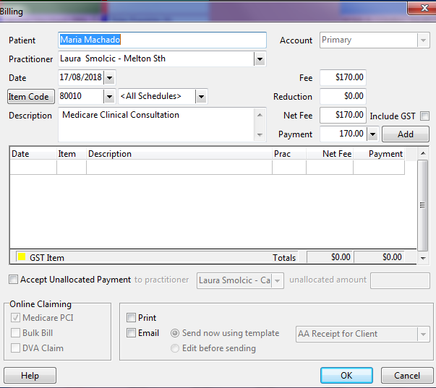
      - Select the appropriate item code
      - Select / check the amount that has populated
      - Once all details are correct, add payment.
      - If client doesn’t pay, do not add “payment”
      - Click add
      - Email invoices to Workcover / TAC, Comcare or other third parties except TPS CLIENTS. (templates are ready to select)
      - If client does not pay, make an event in FD to explain why and when they will pay.

TPS BILLING
TPS clients are entitled to 12 funded sessions per calendar year with a health care card.
- Check events for previous session approval
- Check previous transactions and count the number of sessions held
- Follow billing process but do not send account.
- Accounts for are entered into refer direct weekly.

Item codes (regularly used)

80010 - Medicare Clinical Consultation (Clinical Psychologist)
$124.50 rebate from Medicare
$124.50 is the Bulk Bill amount

All WorkCover consultations
PS602 - Workcover Consultation $167.33 (Fee is the same across all Workcover invoices. Examples of Workcover agencies include Gallagher Bassett, Allianz, Xchanging, Comcare.

