APS News update: 24 July 2020

Update: Advice regarding the use of face masks
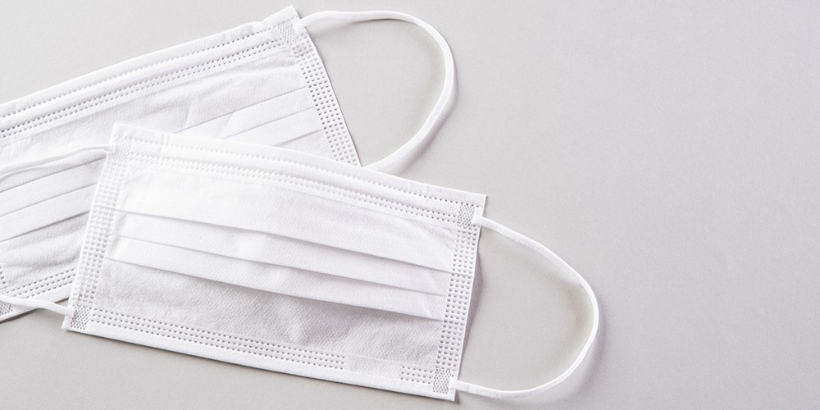
The Victorian Department of Health and Human Services (DHHS) has advised that from midnight on Wednesday 22 July 2020, all residents living in metropolitan Melbourne or Mitchell Shire must wear a face covering when leaving home.
The DHHS has clearly stated that health care workers must wear a level 1 or type 1 disposable surgical mask in public-facing areas – particularly where adequate social distancing is not possible.
At this stage, the APS has not been advised of any specific exemption for psychologists, and therefore psychologists should follow Government advice and wear a face mask until further information can be provided.
Wherever possible and clinically appropriate, psychologists should continue utilising telehealth consultations.
Further guidance on the use of face masks and Personal Protective Equipment (PPE) for health workers can be found on the DHHS website.
Exemptions
According to the DHHS Victoria website, a face covering is not required in specific circumstances including:
- Infants and children under the age of 12 years.
- A person who is affected by a relevant condition - including problems with their medical conditions, breathing, a serious condition the face, a disability or a mental health condition.
- Persons who are deaf or hard of hearing, where the ability to see the mouth is essential for communication.
- Persons for whom wearing a face covering would create a risk to that person’s health and safety related to their work, as determined through OH&S guidelines.
A full list of exemptions is available on the DHHS Victoria website.
Accessing face masks
Psychologists can contact the Primary Health Networks (PHN) in their region to request access surgical masks from the national stockpile.
The DHHS has also announced today that it will be distributing 2.1 million reusable face masks to vulnerable Victorians to help slow the spread of coronavirus. Read more on the DHHS websit

